Cấu hình validate cho modal

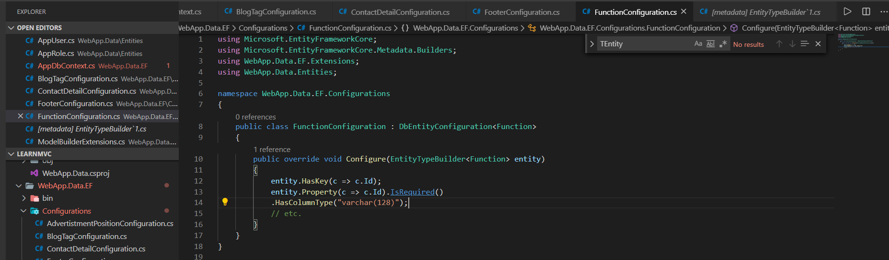

<https://docs.microsoft.com/en-us/dotnet/api/microsoft.entityframeworkcore.metadata.builders.entitytypebuilder.property?view=efcore-3.1>

<https://docs.microsoft.com/en-us/dotnet/api/microsoft.entityframeworkcore.metadata.builders.propertybuilder?view=efcore-3.1>